

INSTALLATION AND OPERATION MANUAL

Model Number: FA-60SK.FA-30SK

Mixer Amplifiers with Mp3/FM/BT
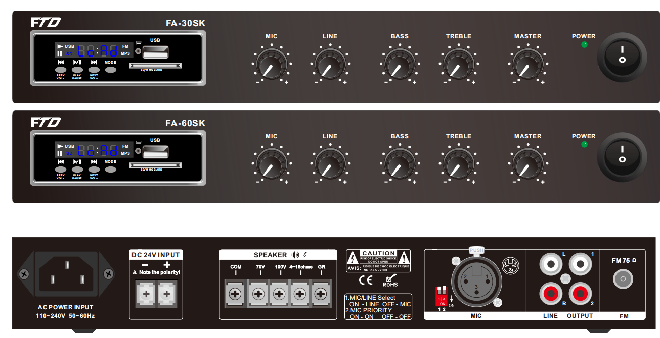




Caution: Please read this manual carefully before operating
Damage caused by misuse is not covered by the warranty

SAFTY WARNINGS!
- Read and keep these instructions.
- Heed all warnings and follow all instructions.
- Do not use this apparatus near water.
- Do not block any ventilation openings. Install in accordance with the manufacturer’s instructions.
- Do not install near any heat sources such as radiators, heat registers, stoves, or other apparatus that produce heat.
- Do not defeat the safety purpose of the polarized or grounding-type plug. A polarized plug has two blades with one wider than the other. A grounding type plug has two blades and a third grounding prong. The wide blade or the third prong is provided for your safety. If the provided plug does not fit into your outlet, consult an electrician for replacement of the obsolete outlet.
- Protect the power cord from being walked on or pinched particularly at plugs, convenience receptacles, and the point where they exit from the apparatus.
- Only use attachments/accessories specified by the manufacturer.
- Use only with the cart, stand, tripod, bracket, or table specified by the manufacturer, or sold with the apparatus. When a cart is used, use caution when moving the cart/apparatus combination to avoid injury from tip-over.
- Unplug this apparatus during lightning storms or when unused for long periods of time.
- Refer all servicing to qualified service personnel. Servicing is required when the apparatus has been damaged in any way, such as power-supply cord or plug is damaged, liquid has been spilled or objects have fallen into the apparatus, the apparatus has been exposed to rain or moisture, does not operate normally, or has been dropped.
- This appliance shall not be exposed to dripping or splashing water and that no object filled with liquid such as vases shall be placed on the apparatus.
- Plug this apparatus to the proper wall outlet and make the plug to be disconnected readily operable.
- Main plug is used as disconnected device and it should remain readily operable during intended use. In order to disconnect the apparatus from the mains completely, the mains plug should be disconnected from the mains socket outlet completely.
- WARNING: To reduce the risk of fire or electric shock, do not expose this apparatus to rain or moisture.
- An appliance with a protective earth terminal should be connected to a mains outlet with a protective earth connection.
WARNING!

TO PREVENT FIRE OR SHOCK HAZARD, DO NOT USE THE PLUG WITH
AN EXTENSION CORD, RECEPTACLE OR OTHER OUTLET UNLESS THE BLADES
CAN BE FULLY INSERTED TO PREVENT BLADE EXPOSURE.
TO REDUCE THE RISK OF FIRE OR ELECTRIC SHOCK, DO NOT EXPOSE
THIS APPLIANCE TO RAIN OR MOISTURE.
TO PREVENT ELECTRICAL SHOC
K, MATCH WIDE BLADE PLUG TO WIDE SLOT, FULLY INSERT.

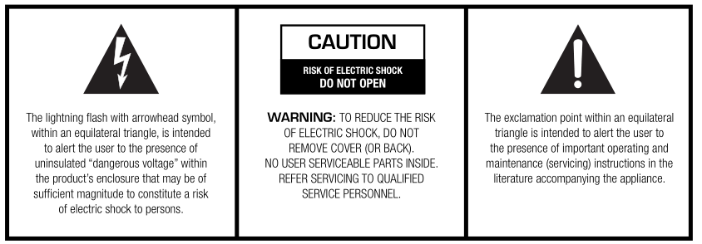

INTRODUCTIONS

Description
The PA Mixer Amplifier is with simple and compact size design, its rated power output from 30W, 60W , it is ideal for school, super market, bank, hotel BGM and speech use. It is all in one solution with two sources, pre amplifier and mixer power amplifier into one unit, which is economy but of high reliable performance.

It integrates 2 audio sources into a mixer amplifier, plus Mic1 and Line input1 (RCA), simple and easy to operate.
The amplifier is designed with complete protection of overload, short circuit and high temp to avoid any damage.
These amplifiers are suitable for applications in bank, mosque, school, hotel, restaurant, theme centers and shopping center.

Features
- Compact mini size public address amplifier
- Ideal for classroom sound system use
- Built-in 100V/70V transformer technology
- Built in MP3/SD/Bluetooth/FM tuner
- Rate power output at 30W, 60W.
- Speaker output of 100V or 70V & 4Ohms-8 Ohms-16 Ohms
- Mic1and line 1. Mic1 of balanced XLR input on rear panel. Line 1 input of RCA input and one RCA line output.
- Priority and Line /MIC switchable
- Volume control for Mic1, line1, bass/treble and master
- With short-circuit, clip, overload and high temp protection
- DC24V, AC220V or 115V input

FRONT PANEL
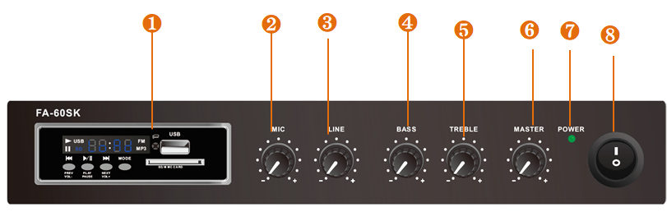

- MP3/SD/FM/Bluetooth Player
- Mic1 Attenuator.
- Line Input 1Attenuator.
- Bass
- Treble
- Power indicator.
- AC power switch.
- Mic1 Attenuator.

REAR PANEL
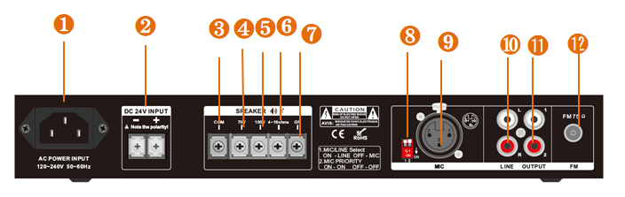

- AC Power Socket.
- DC24V input
- Speaker output COM.
- Speaker output 70V (+).
- .Speaker output 100V (+).
- Speaker output 4-16 Ohms (+)
- GND
- Switch for Priority and Line/Mic
- Mic1 input.
- Line input.
- Line Output.
- FM antenna

AMPLIFIER OPERATION GUIDANCE

100V Line System
For 100V line systems, connect the amplifier to the first speaker in the system using double-insulated speaker wire which has adequate current rating to handle the total output of the amplifier.
Connect the “100V” output terminal to the positive (+) connection of the speaker and “COM” output to the negative (-) connection of the speaker. Connect further speakers in parallel to the first speaker with all positive terminals and connected together and all negative terminals connected together as shown below.
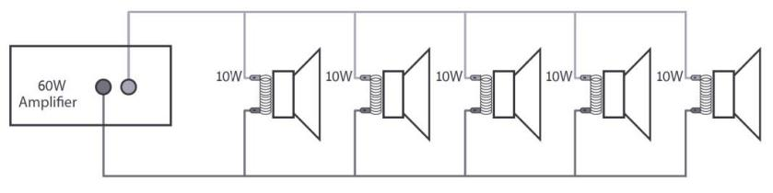
A 100V line speaker system can comprise of many speakers connected together. The determining factor for how many speakers can be used on a single amplifier is the power rating. For most purposes, it is advised to connect as many speakers as needed with a combined wattage of no more than 90% of the amplifier’s output power rating.
The terminals of a 100V speaker are connected to a transformer and in some cases, this transformer may be “tapped” for different power ratings. These tappings can be used to adjust the wattage (and output volume) of each speaker in the system to help achieve the ideal total power of the system for the amplifier.
The mixer amplifier is featured of 6 speaker zone outputs, either one of six zone or total six zone power loading shall be equivalent or no higher than the rated power of the amplifier.

Speaker Terminals
These terminals are offering 3 low voltage outputs 4Ω, 8Ω, 16Ω depending on your speaker combination. A 70V/100V commercial output is also available. Please note that one wire only should be connected to COM screw and one wire to the selected impedance or voltage. Multiple combinations cannot be done at the output level. Four different types of connections are provided. The low impedance section: 4Ω, 8Ω, 16Ω is designed for a small amount of speakers to be connected to your amplifier. The 70V/100V section is especially designed for a multiple speaker distribution. When using the 70V/100V output, speakers have to be equipped with 70V/100V transformer. The maximum amount of speakers to be placed on your distribution line is in relation to the power allocated to each speaker. The total wattage set on the secondary side of the transformers on your speaker line must not exceed the maximum RMS output power: 30W, 60W. Failure to respect this may cause permanent damage to the amplifier

Speaker Connections
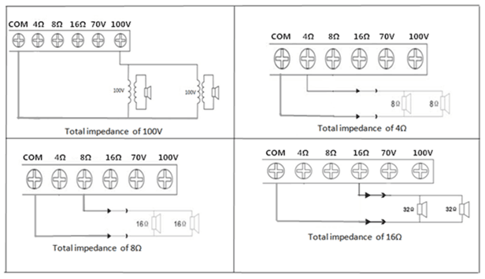

Operation Steps
- When all connections to the amplifier are made, turn all rotary controls down and switch on the power and a power “ON” LED will illuminate. Turn BASS and TREBLE controls to the 12 o’clock position (pointing straight up) and turn MASTER rotary control up part way for testing.
- Ensure a signal is being fed to one of the line inputs 1and gradually increase the volume control for that channel until the output is heard through the speakers. Turn up the MASTER to the maximum required volume level and reduce the channel volume control if necessary..
- If a microphone is connected to MIC1 input, make sure it is switched on and if it requires phantom power, make sure this feature is enabled. Gradually increase its volume control whilst speaking into the microphone until the required volume level is reached. The microphone should not be able to “hear” the speakers, which can cause feedback (squealing or howling noise).
- If the VOX feature is enabled, audio playback through line input will be reduced in volume automatically when speaking into MIC 1, use its attenuator to increase or decrease the mute level.
- In addition to channel and MASTER volume controls, there are BASS and TREBLE EQ controls to adjust the tone of the overall output. At the 12 o’clock position, these controls are applying no effect to the signal (no boost or cut). Moving the BASS control clockwise boosts the low frequencies in the audio, whilst moving it anticlockwise will cut these low frequencies. Likewise, moving the TREBLE control clockwise boosts the high frequencies in the audio, whilst moving it anticlockwise will cut these high frequencies. Adjust these EQ controls to suit the type of audio signal or compensate for the room acoustics.

CONNECTION DIAGRAMS
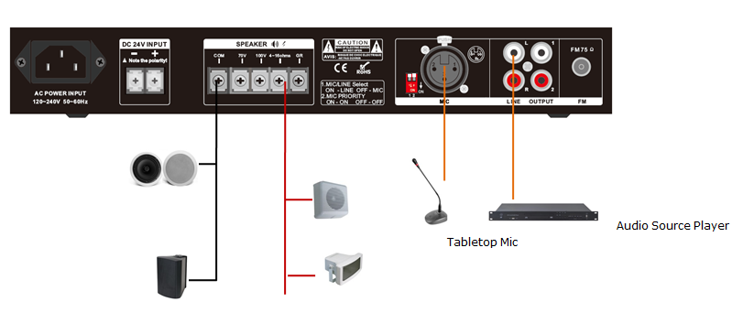

SPECIFICATION SHEET

Model | FA-30SK | FA-60SK
Description | PA Amplifier with USB/SD & FM & Blue Tooth
Rated Power Output | 30W | 60W
Speaker Outputs | 100V or 70V & 4Ohms-8 Ohms-16 Ohms
Connector | Mic1 input by XLR  Line inputs by RCA; Line output by RCA
Attenuation | Microphone1 line1 and Mp3/FM, bass/treble and master
Input | MIC1-3: 5-8mV, 600Ω; Line, 150-470mV, 10KΩ, unbalanced RCA
Line Out | 0.775(0dBV)
Frequency Response | 60Hz-15kHz(±3dB)
S/N Ratio | Line ≥ 85dB, Mic≥ 72dB
THD | Less than 0.5%
Protection | short-circuit, clip, overload and high temp protection
Power Consumption | 37.5W | 75W
Power Supply | AC220V or 115V & 24V DC /50-60Hz
Dimension | 308(W)×230(D)×45(H)mm
Weight | 2.9kg | 3kg

Specifications may change without pre-notice.

